Web JDBC資料庫 Stored Procedure使用
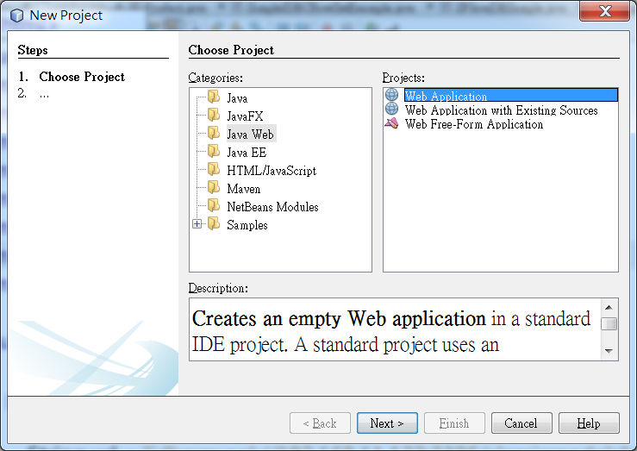
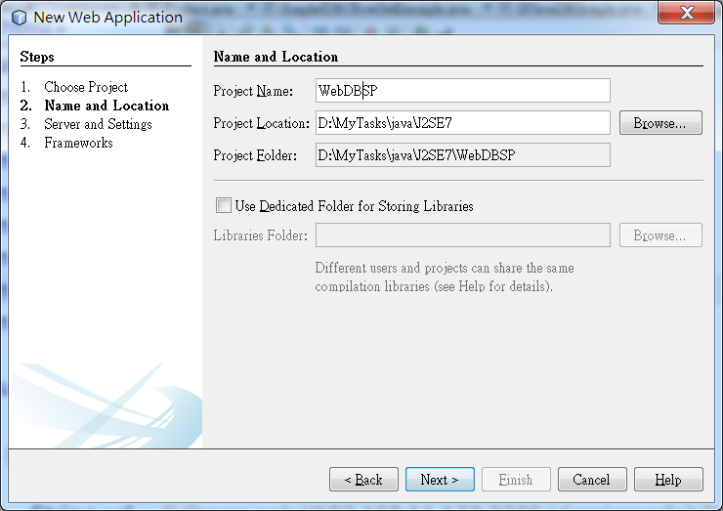
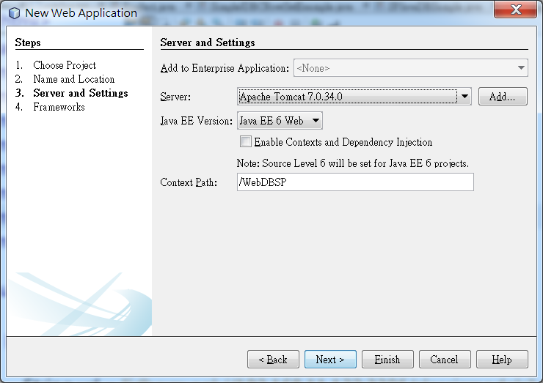
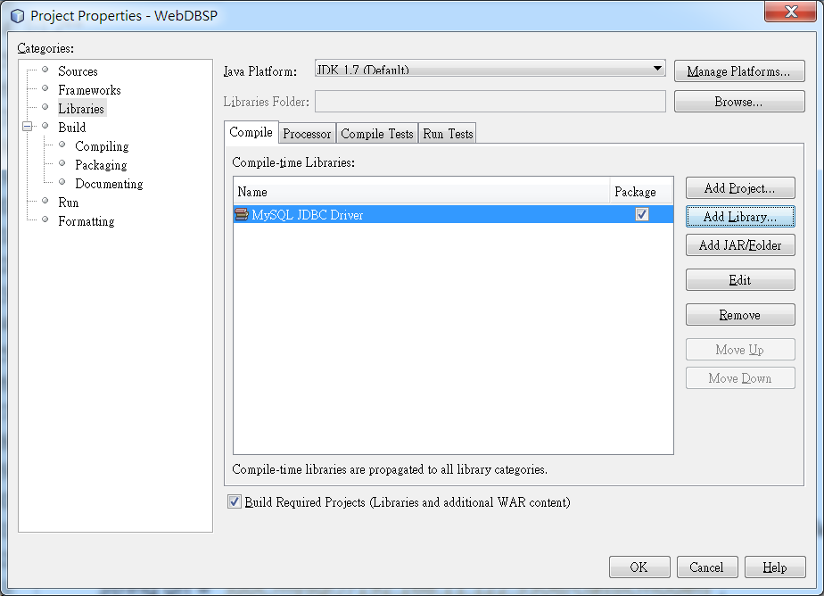
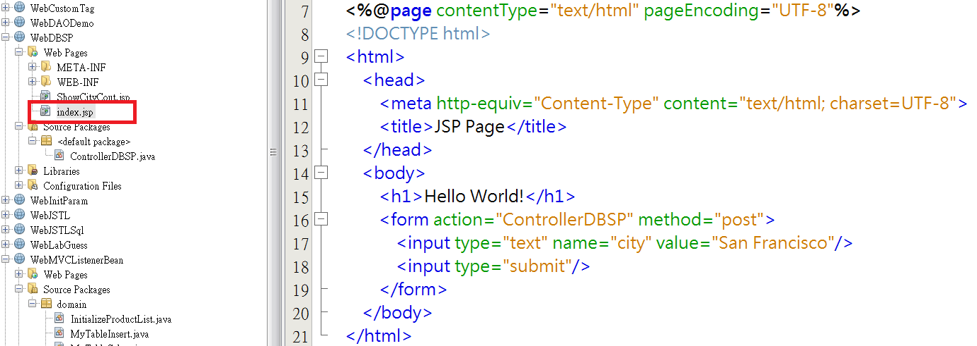
1. index.jsp
<%@page contentType="text/html" pageEncoding="UTF-8"%>
<!DOCTYPE html>
<html>
<head>
<meta http-equiv="Content-Type" content="text/html; charset=UTF-8">
<title>JSP Page</title>
</head>
<body>
<h1>Hello World!</h1>
<form action="ControllerDBSP" method="post">
<input type="text" name="city" value="San Francisco"/>
<input type="submit"/>
</form>
</body>
</html>

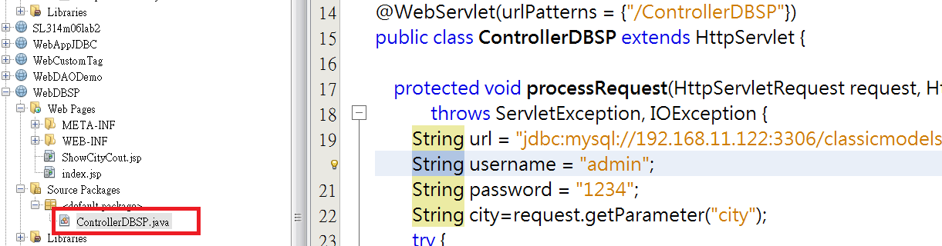
2. ControllerDBSP.java

import java.io.IOException;
import java.io.PrintWriter;
import java.sql.CallableStatement;
import java.sql.Connection;
import java.sql.DriverManager;
import java.sql.Types;
import javax.servlet.ServletException;
import javax.servlet.annotation.WebServlet;
import javax.servlet.http.HttpServlet;
import javax.servlet.http.HttpServletRequest;
import javax.servlet.http.HttpServletResponse;

@WebServlet(urlPatterns = {"/ControllerDBSP"})
public class ControllerDBSP extends HttpServlet {

protected void processRequest(HttpServletRequest request, HttpServletResponse response)
throws ServletException, IOException {
String url = "jdbc:mysql://192.168.11.122:3306/classicmodels";
String username = "admin";
String password = "1234";
String city=request.getParameter("city");
try {
Class.forName("com.mysql.jdbc.Driver");
Connection con = DriverManager.getConnection(url, username, password);
CallableStatement cStmt = con.prepareCall("{CALL GetEmpInOffice(?, ?)}");
cStmt.setString(1, city);
cStmt.registerOutParameter(2, Types.INTEGER);
boolean result = cStmt.execute();
int count = cStmt.getInt(2);
request.setAttribute("citycount", ""+count);
request.getRequestDispatcher("ShowCityCout.jsp").forward(request, response);
} catch (Exception e) {
System.out.println(e.getMessage());
}
}
@Override
protected void doGet(HttpServletRequest request, HttpServletResponse response)
throws ServletException, IOException {
processRequest(request, response);
}

@Override
protected void doPost(HttpServletRequest request, HttpServletResponse response)
throws ServletException, IOException {
processRequest(request, response);
}

@Override
public String getServletInfo() {
return "Short description";
}// </editor-fold>
}

3. ShowCityCount.jsp
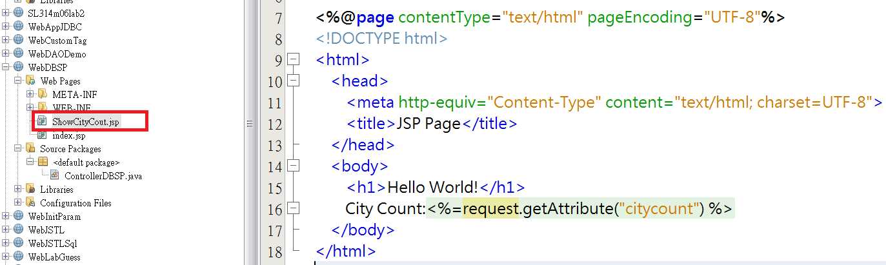

<%@page contentType="text/html" pageEncoding="UTF-8"%>
<!DOCTYPE html>
<html>
<head>
<meta http-equiv="Content-Type" content="text/html; charset=UTF-8">
<title>JSP Page</title>
</head>
<body>
<h1>Hello World!</h1>
City Count:<%=request.getAttribute("citycount") %>
</body>
</html>

